CS6620 Fundamentals of Cloud Computing

**E-Commerce SaaS Web Application -- InstaShop**

**Team Members:**

Guan Wang

Yu Feng

Qichen An

Wenhao Ge

**https://github.com/singinzrain/cloud_computing_ecommerce**

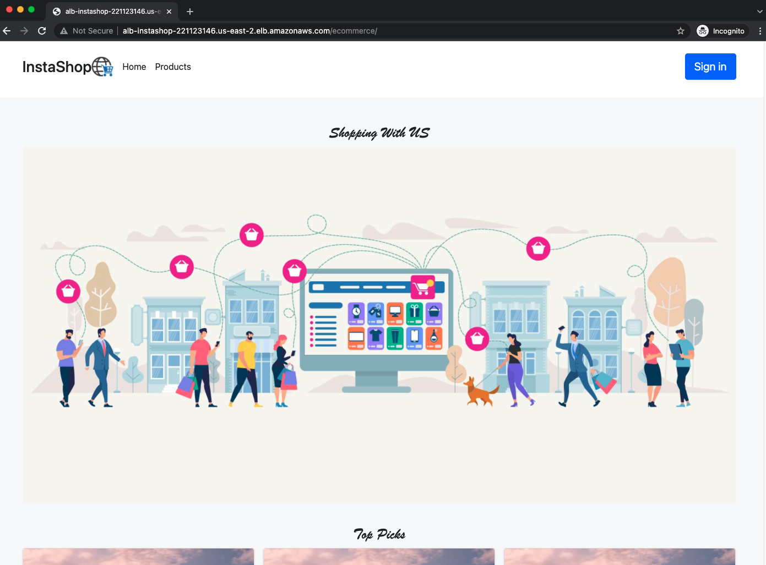

***Project Description:***

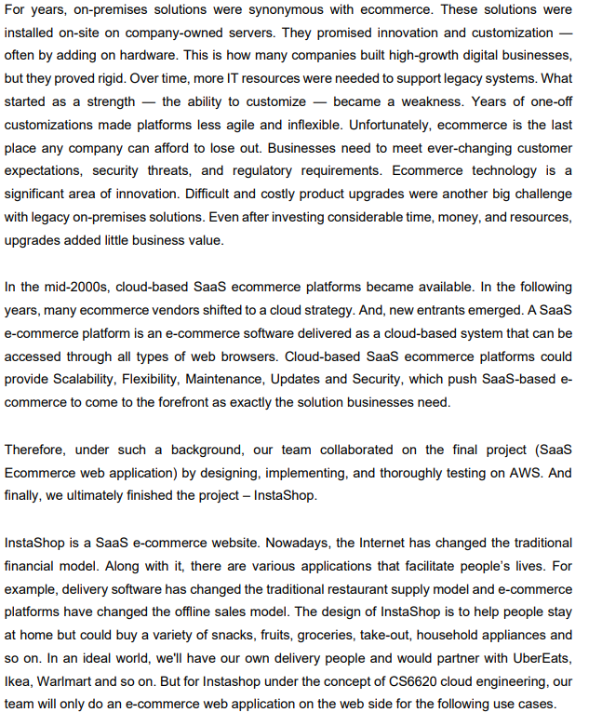

**Use Case:**

As customers go to our website, they will first see our home page which welcomes our customers and informs them with top picked products. They can view all the products as going to the products page. For each listed product, they can click on it which will direct them to a product detail page. From the navigation bar, they can sign up and login with their accounts. After they login, they can add products into the shopping cart, edit the shopping cart and then check out their orders. They can revisit their orders in the order history page.

**Key Features:**

* **Home page**: welcome customers and inform them with top 3 picked products
* **Product page**: showing all the products
* **Product details page**: showing more detail information for the product along with reviews
* **Shopping cart page**: showing a list of customer wanted products and the customer can increase or decrease the product count. The customer can also delete a product from the shopping cart
* **Check out page**: asking customers to fill out needed information and allowing them to check-out
* **History orders**: showing a list of history orders
* **Sign In/Sign Up**: allowing customers to create their account and login

Please note, we mention a search product feature in our project proposal. But, we think Sign In/Sign Up is a more important feature. Thus, we decided to implement the Sign In/Sign Up feature rather than the search product feature.

**Architecture overview diagram (AOD) and design description**

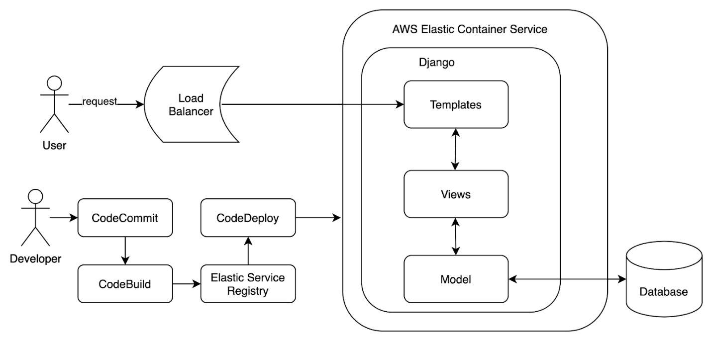

For a high-level view, users will send out requests which would be sent through a load balancer and directed to an AWS instance. In the AWS instance, our web application will be implemented with Django where requests would go through related templates, views, and models.

From the perspective of developers, AWS Codepipeline is leveraged.  The code update will be pushed to CodeCommit repo, then CodeBuild is triggered to build a docker image and the image will be pushed to Elastic Service Registry. Finally, CodeDeploy is triggered to start the container from the image and deploy the service to ECS cluster.

**Cloud Features:**

For the implementation, our group use following AWS features:

1. AWS Elastic Container Service

We deploy our containerized application service through ECS.

1. Load Balancer

Route incoming end-users’ traffic to applications based in the AWS cloud.

1. Amazon RDS

We use AWS RDS to store our structured data.

1. Complete CI/CD

Automate build and deployment with AWS CodeCommit, AWS CodeBuild, AWS CodeDeploy, and AWS CodePipeline.

1. AWS Lambda

In our deployment process, we tried to use zappa to deploy our web app which involves AWS Lambda.

**Deployment Process**

Create Dockerfile for the application

FROM python:3

ENV PYTHONDONTWRITEBYTECODE=1

ENV PYTHONUNBUFFERED=1

WORKDIR /code

COPY requirements.txt /code/

RUN pip install -r requirements.txt

COPY . /code/

EXPOSE 8000

CMD ["python", "manage.py", "runserver", "0.0.0.0:8000"]

Create CodeCommit and upload the code files

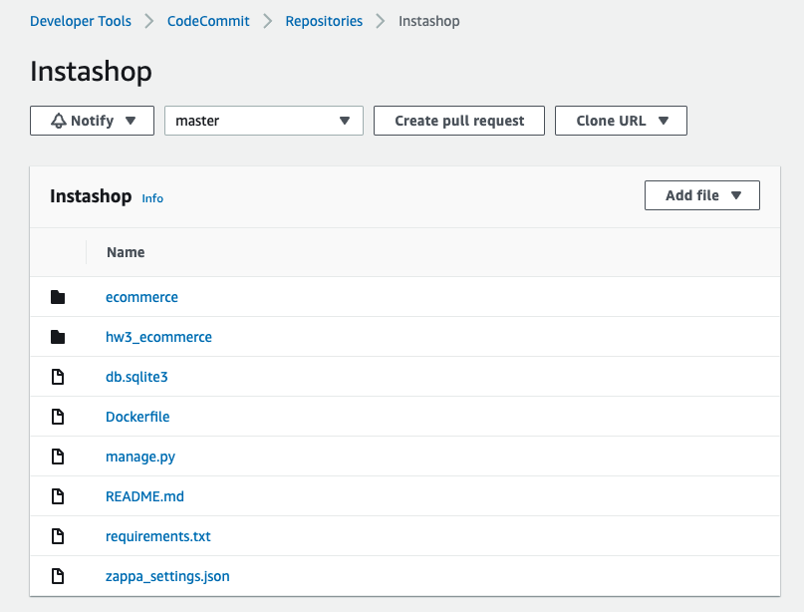

Create Codebuild and make the source as the Instashop from CodeCommit, make sure the codebuild environment image is privileged

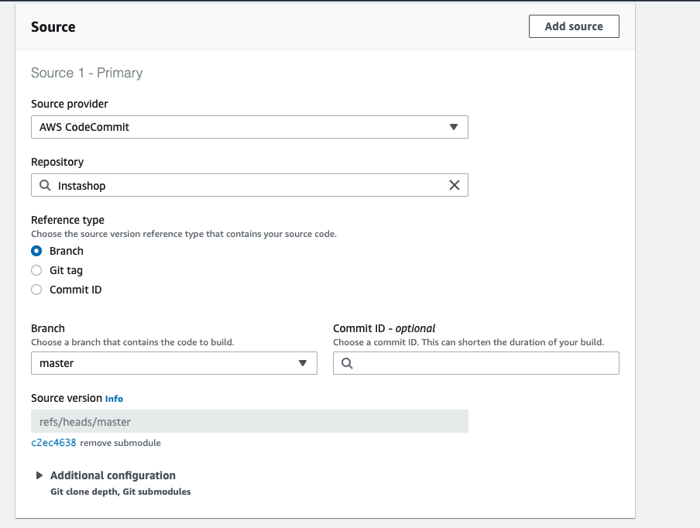

Add buildspec.yaml

version: 0.2

​

phases:

pre_build:

  commands:

    - echo Logging in to Amazon ECR...

    - $(aws ecr get-login --no-include-email --region $AWS_DEFAULT_REGION)

build:

  commands:

    - echo Build started on `date`

    - echo Building the Docker image...

    - docker build -t instashop:1 .

    - docker tag instashop:1 632547974315.dkr.ecr.us-east-2.amazonaws.com/yufengcloud

post_build:

  commands:

    - echo Build completed on `date`

    - echo Pushing the Docker image...

    - docker push 632547974315.dkr.ecr.us-east-2.amazonaws.com/yufengcloud

artifacts:

files: imagedefinition.json

Add imagedefinition.json

[

{

  "name": "instashop",

  "imageUri": "632547974315.dkr.ecr.us-east-2.amazonaws.com/yufengcloud:latest"

}

]

Add policy to the codebuild role  
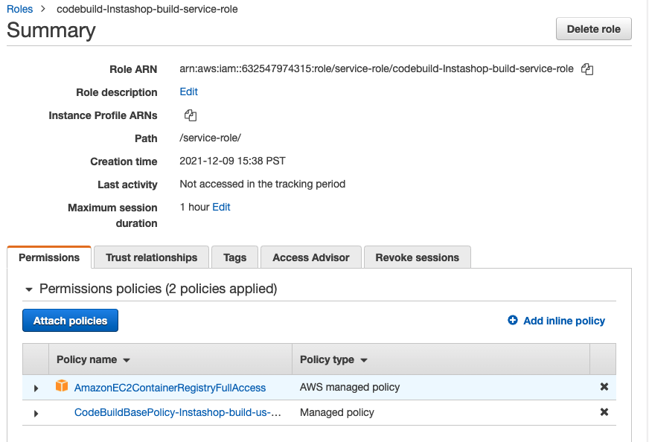

Successfully built image

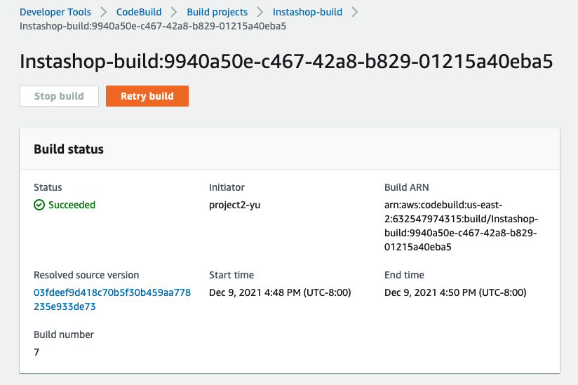

Verify the image in ECR

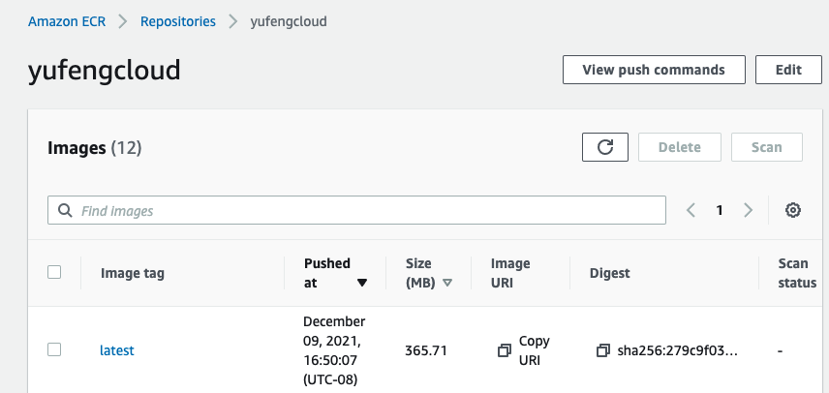

Create task

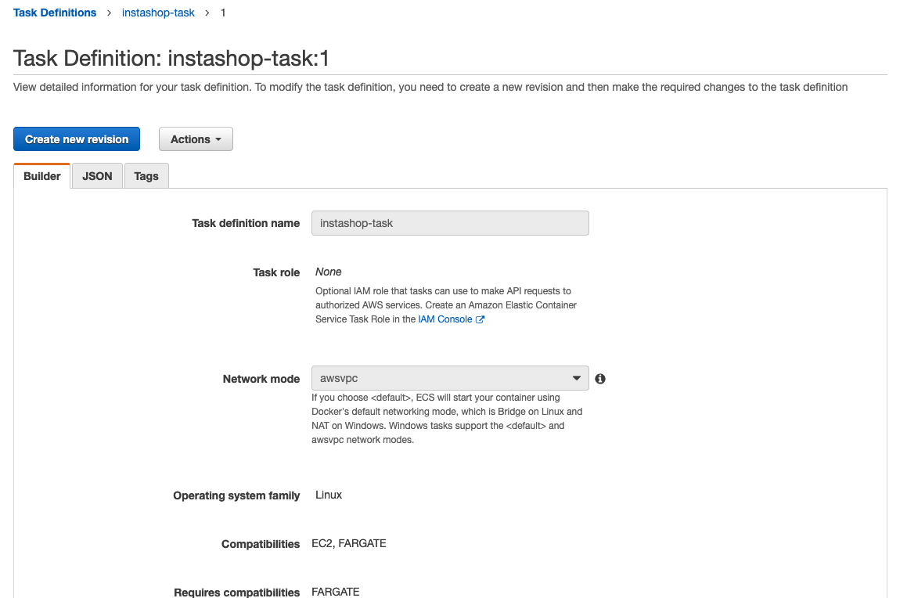

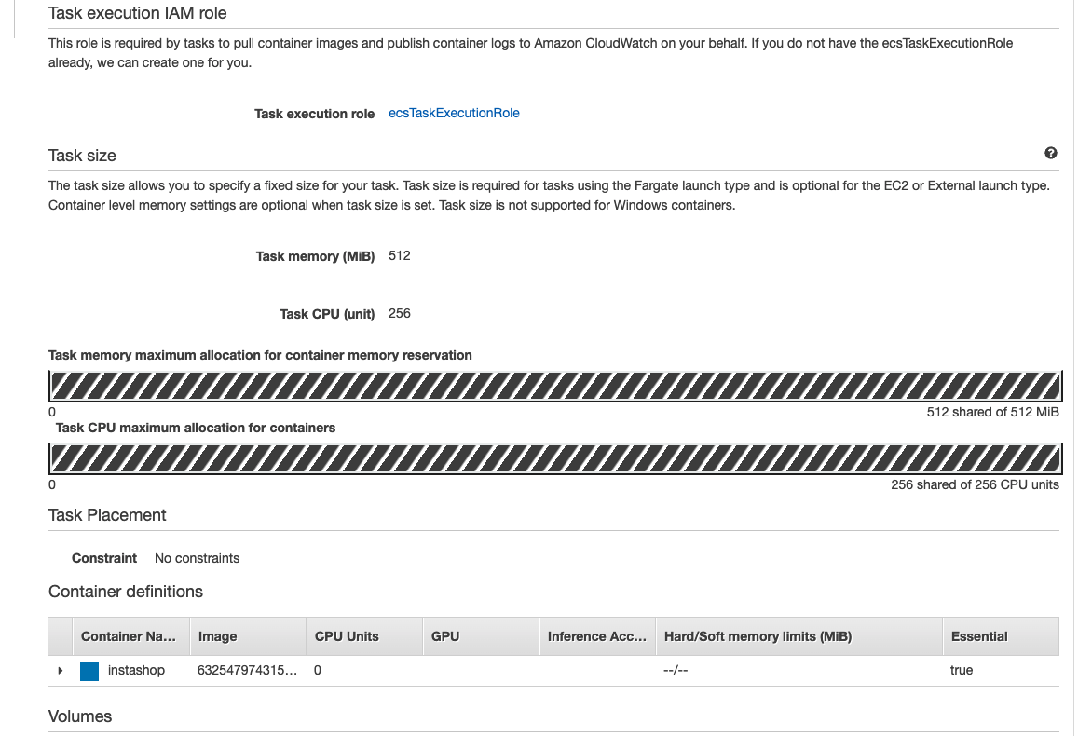

Create ALB

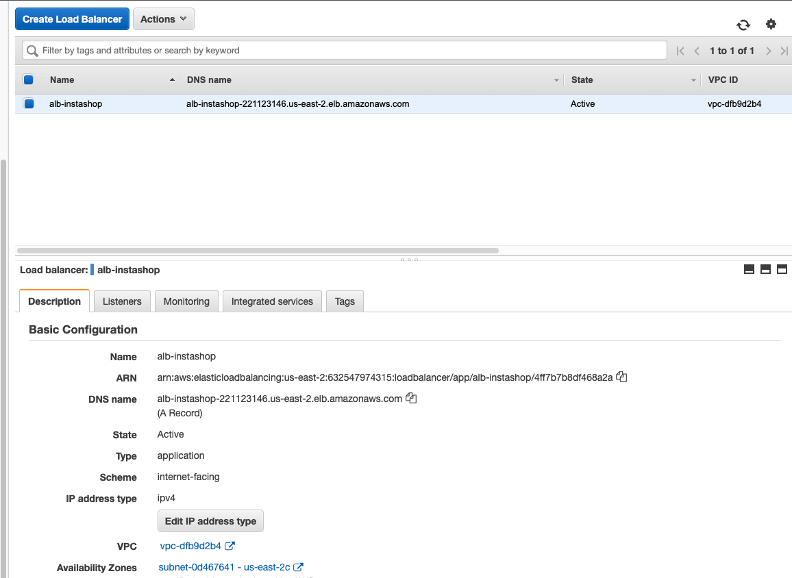

Create Cluster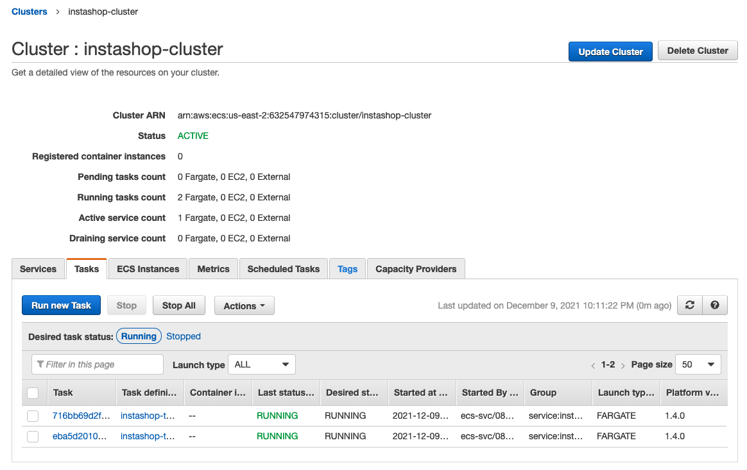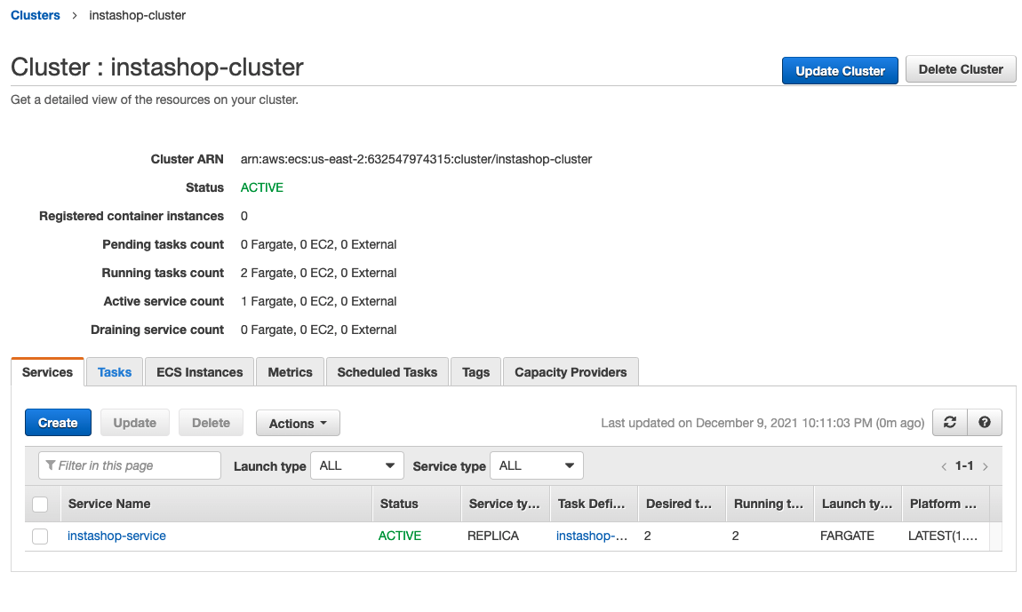

Create CodePipeline and execute successfully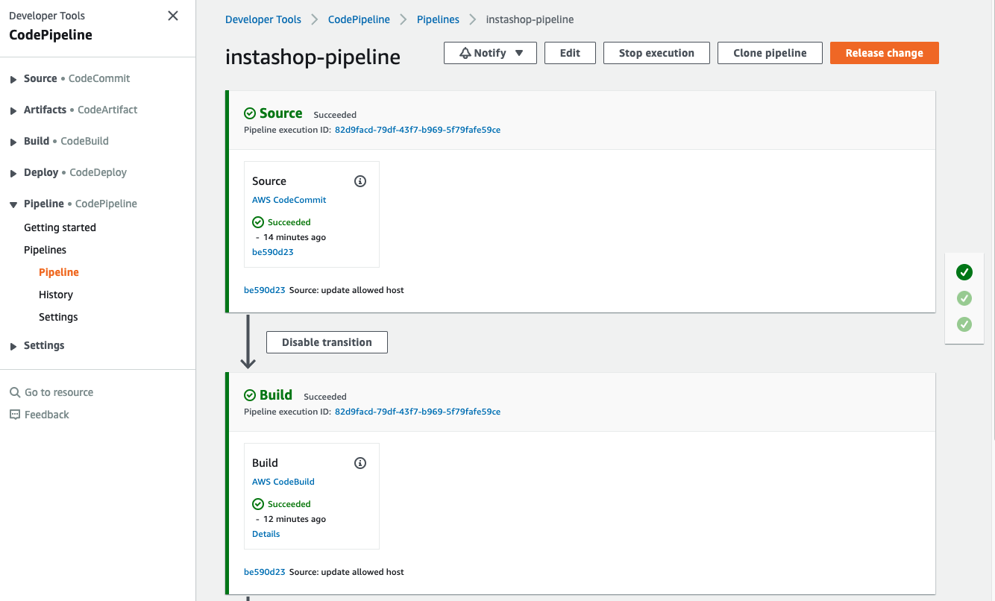

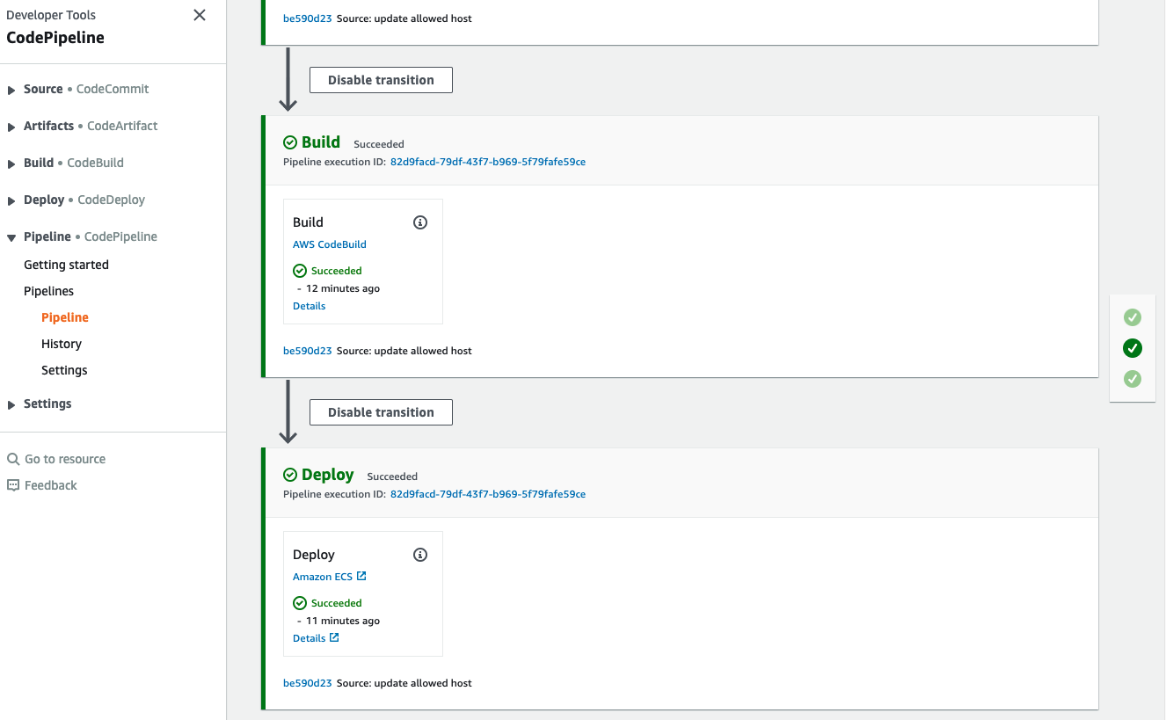

AWS Relational Database Service

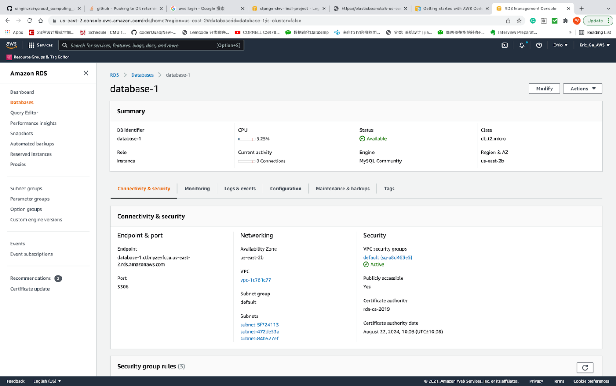

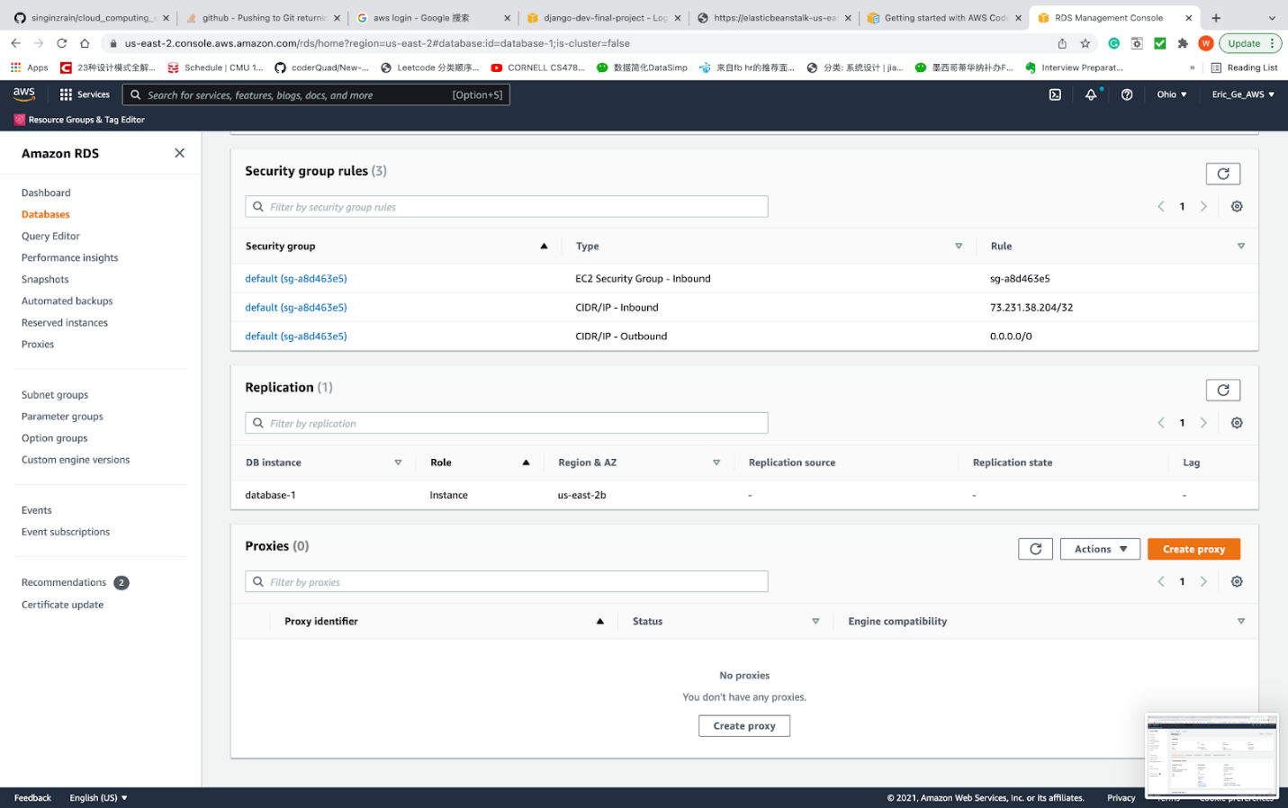

Verify the deployed web app is working

<http://alb-instashop-221123146.us-east-2.elb.amazonaws.com/ecommerce/>



**UI & HCI**

Home Page (without user logged in)





Sign In Page

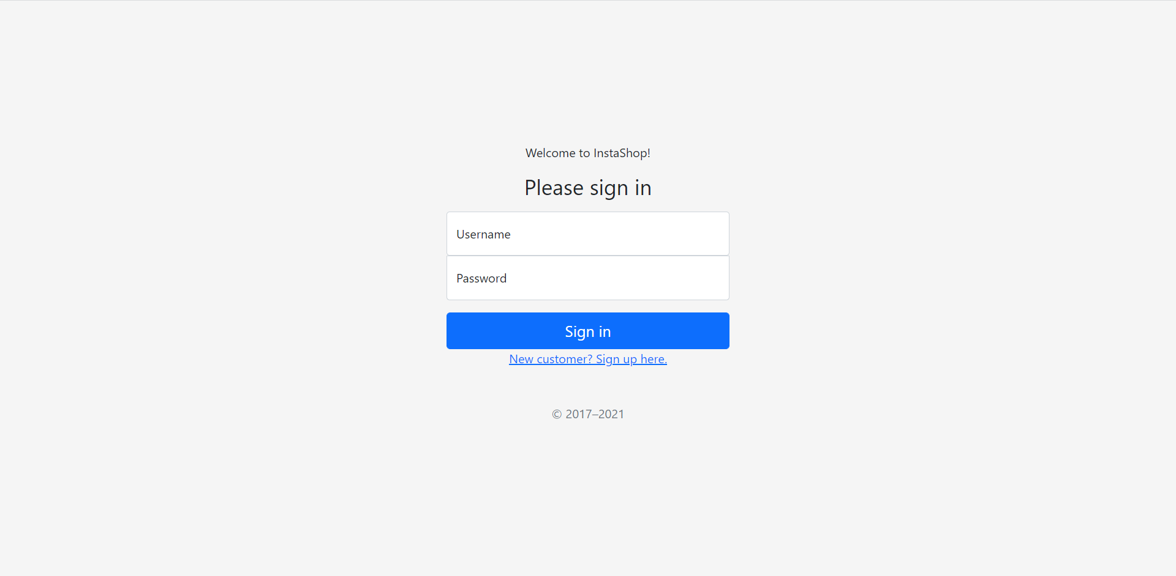

Sign Up Page

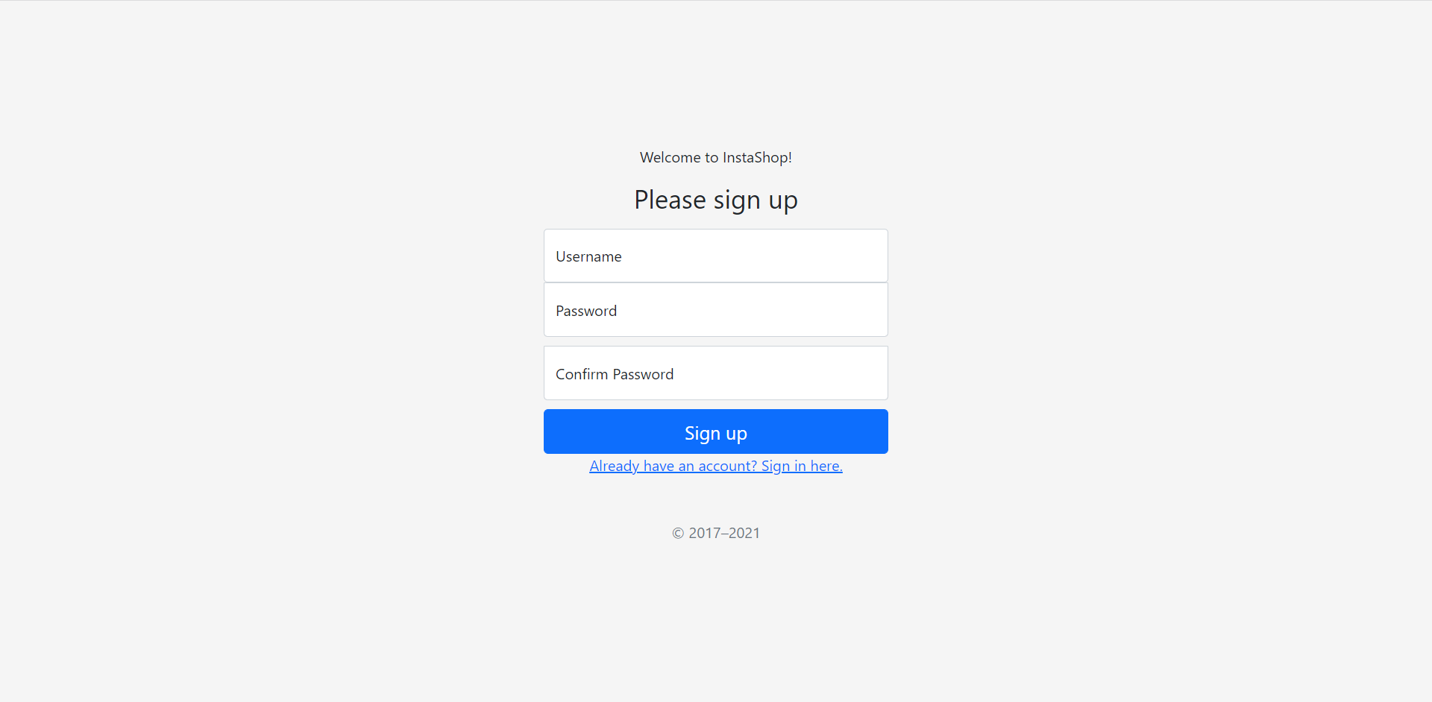

Here is an example, we create a guest for this system.

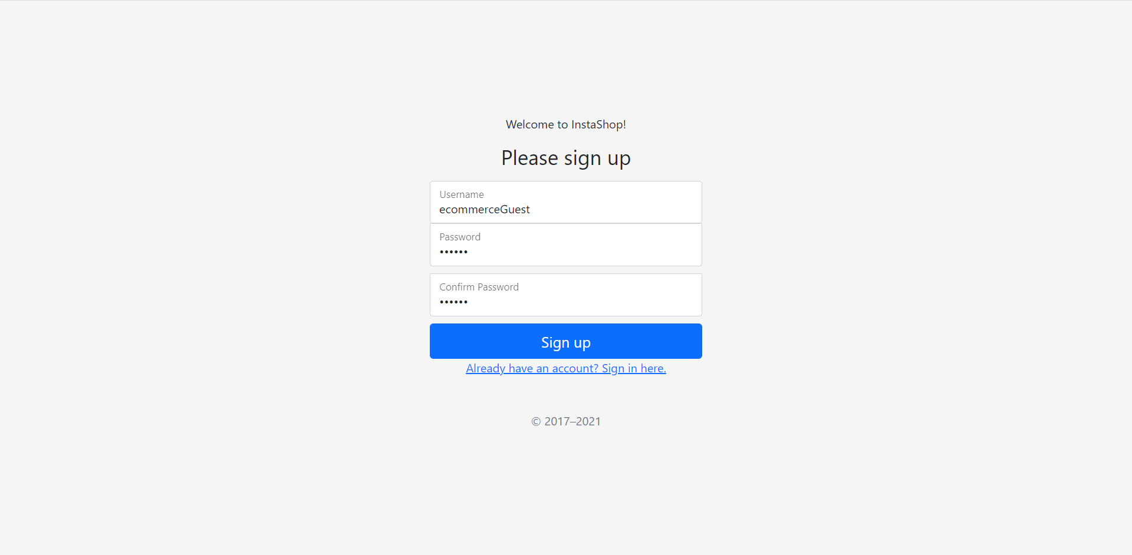

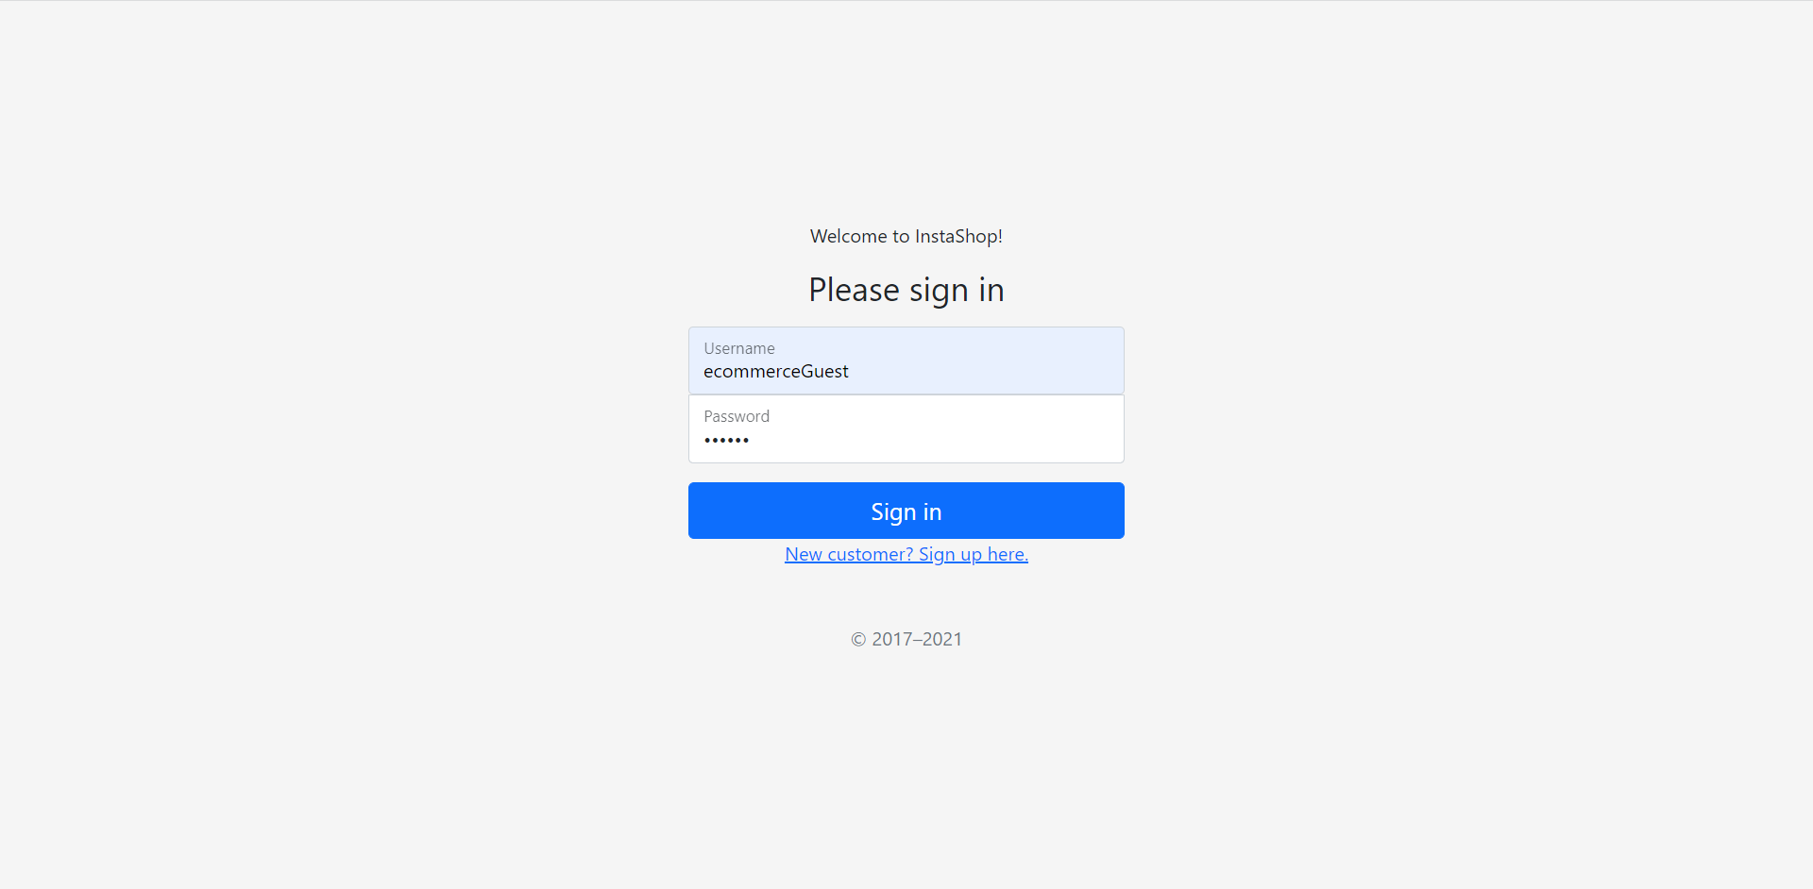

Home Page with user logged in

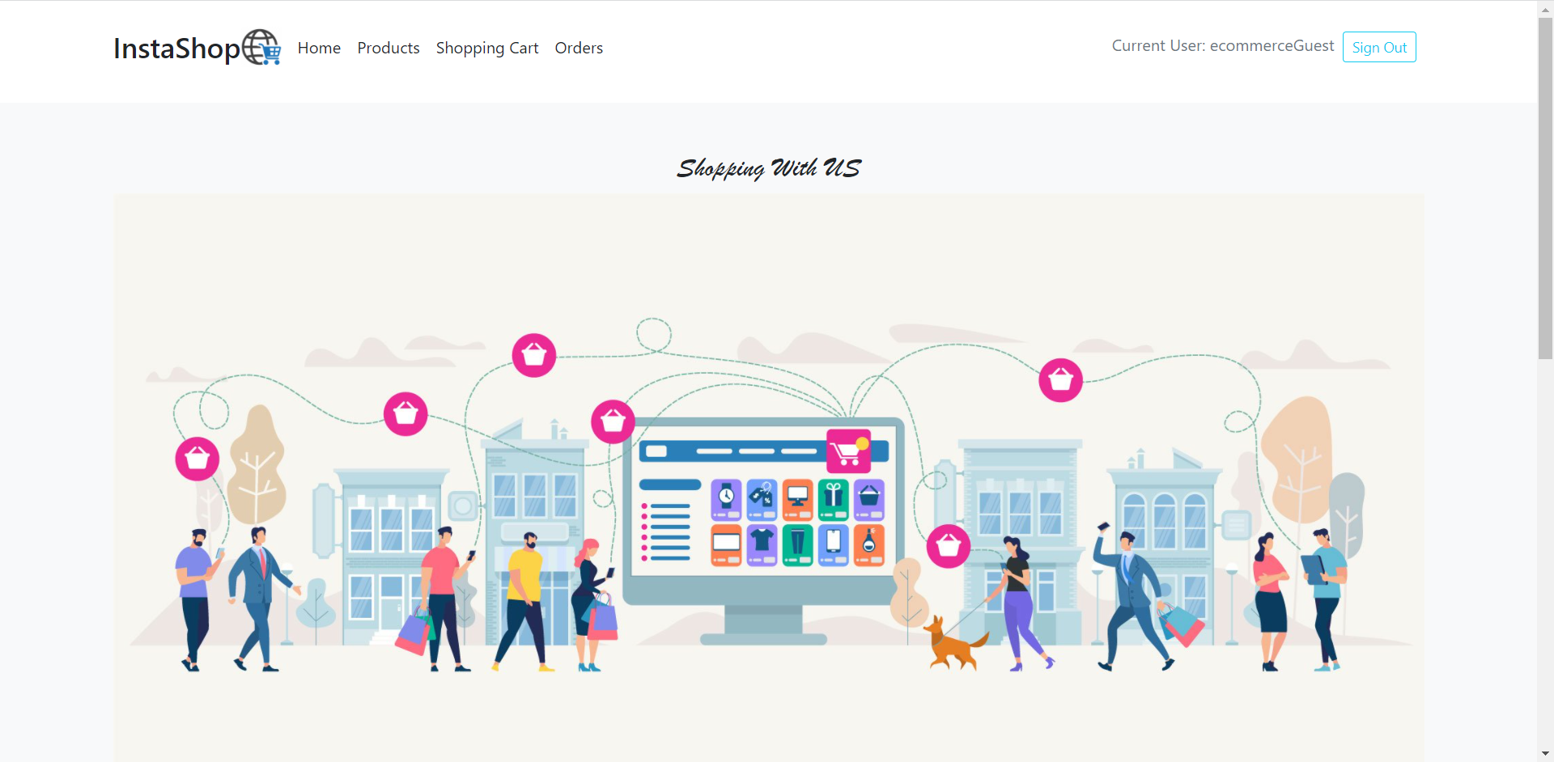

Products Page

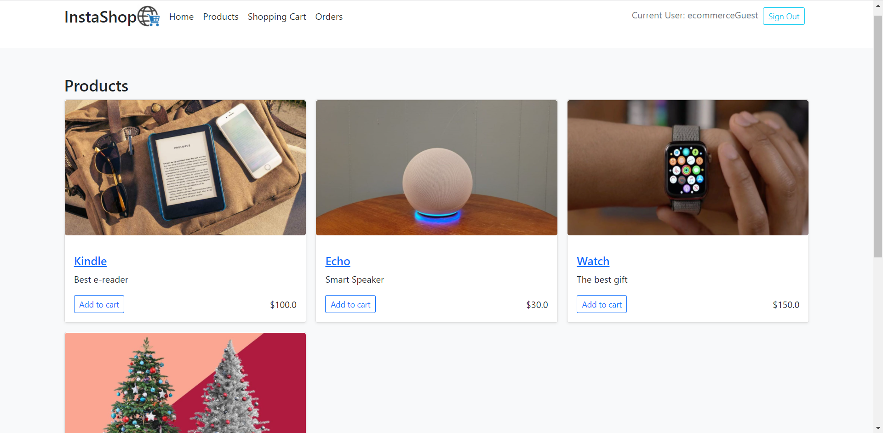

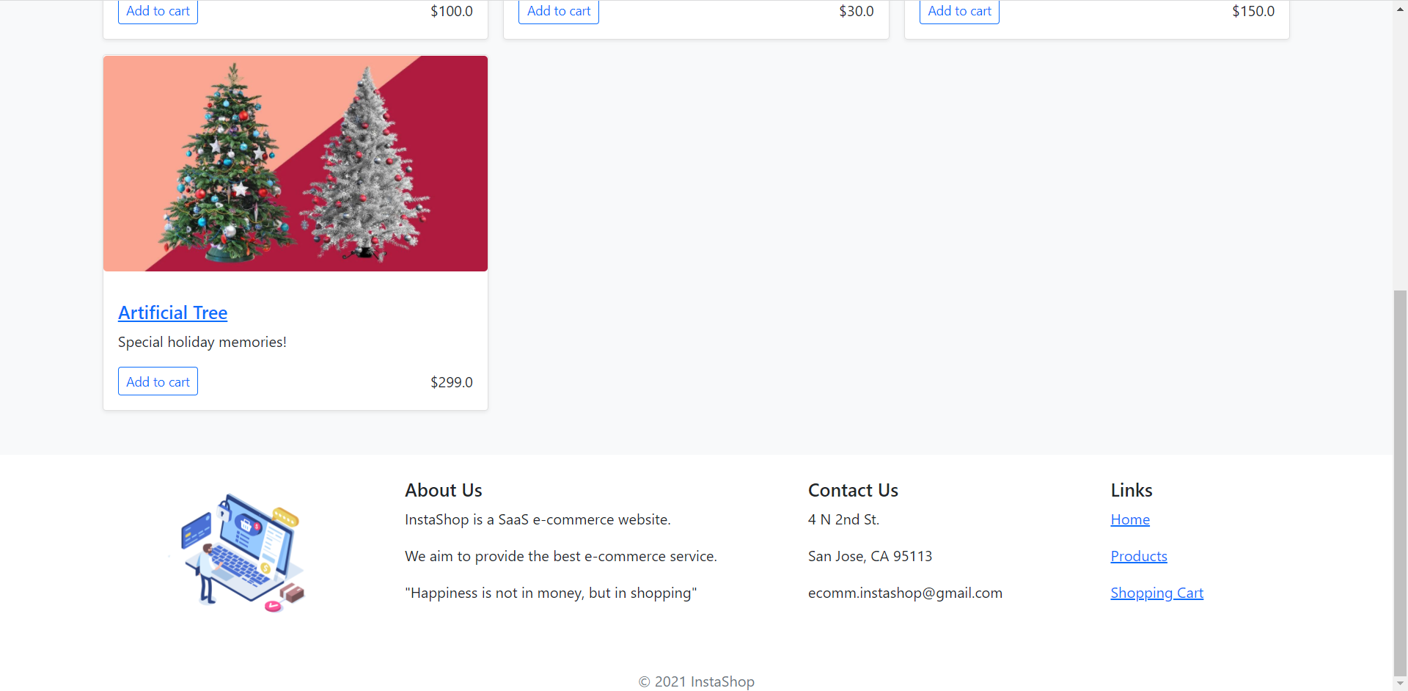

Product Details Page

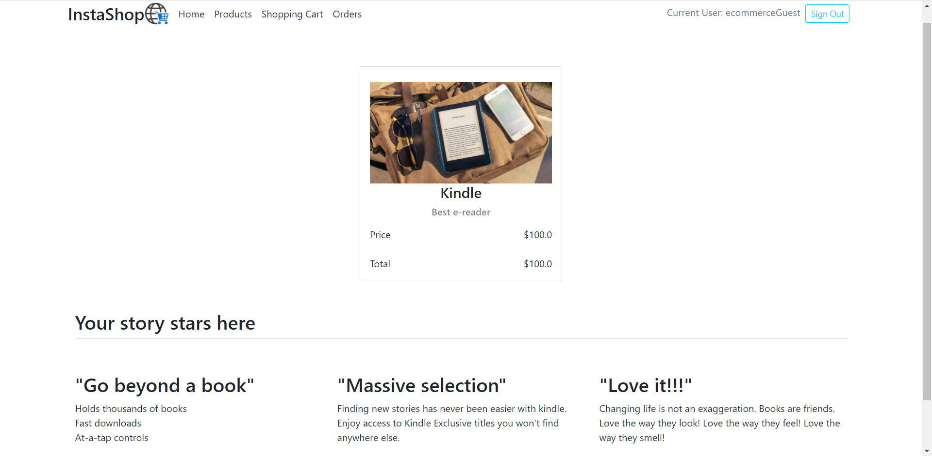

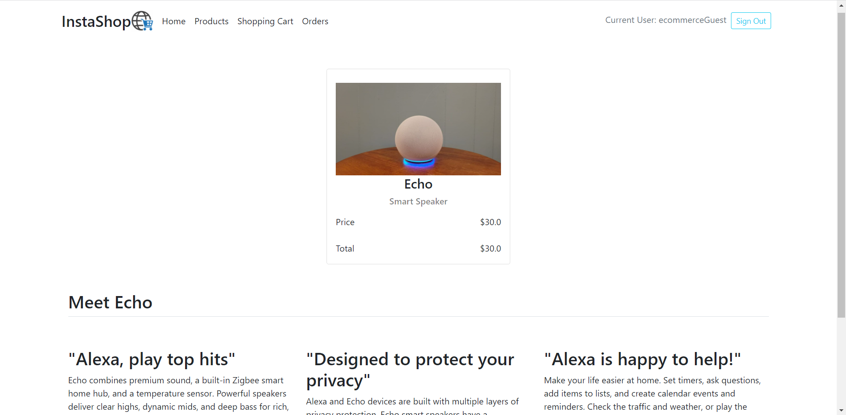



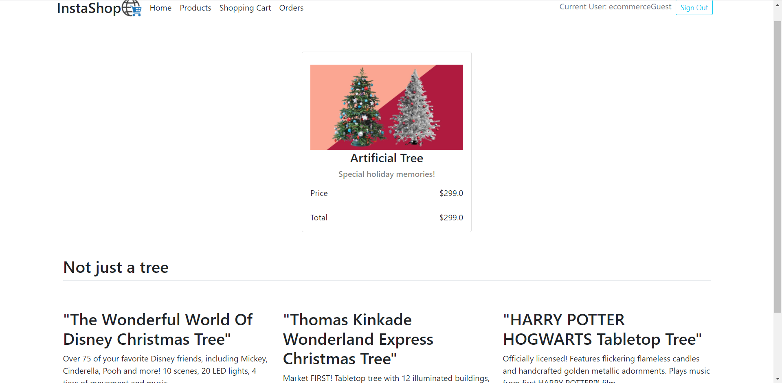

If the user wants to buy one product, he or she just need to click ‘add to cart’ button and then receive a prompt for success.

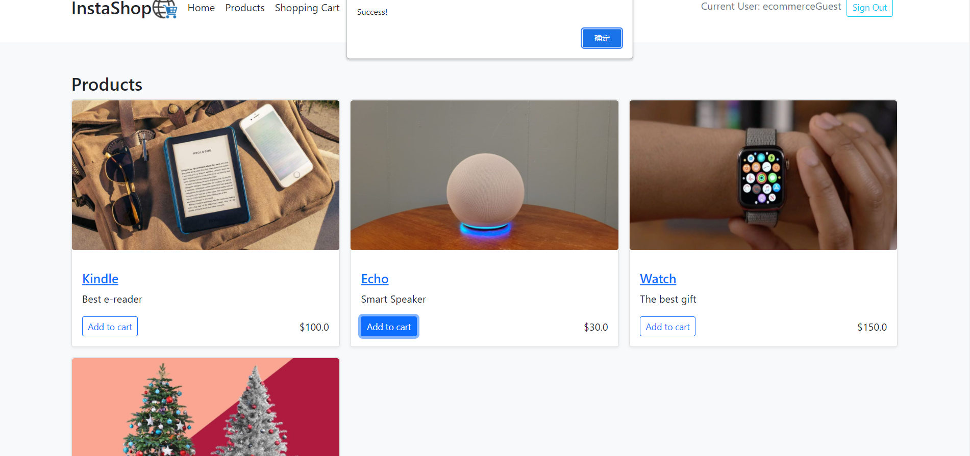

Then, you can see the products are already in the shopping cart.

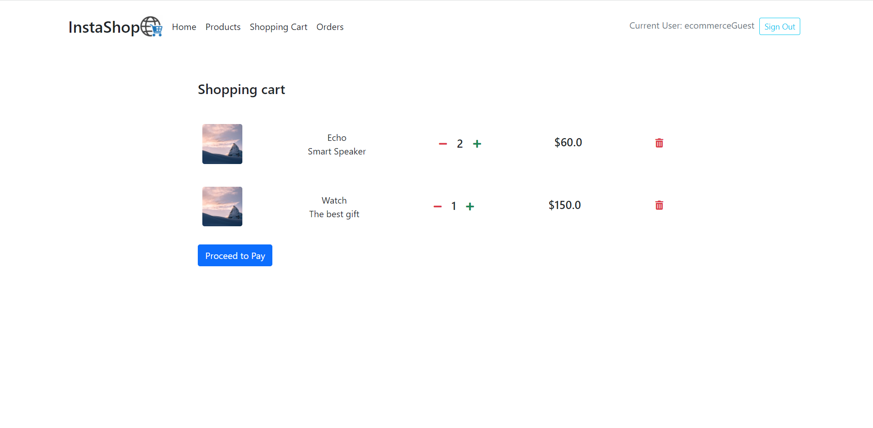

After click ‘Proceed to Pay’ button, you will be redirected to the checkout page.

The checkout page will show you the summary of the order, and require the users filling shipping details and payment information.

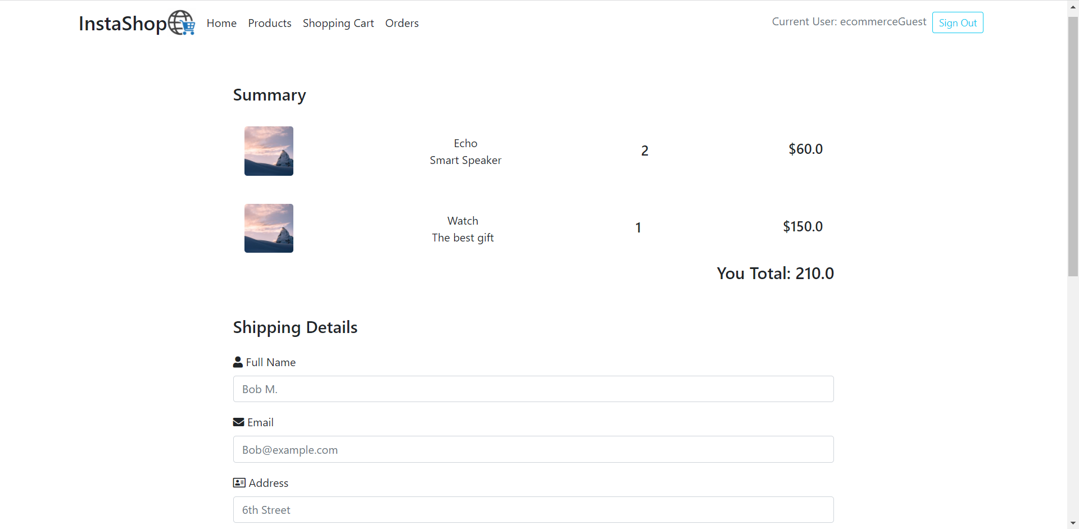

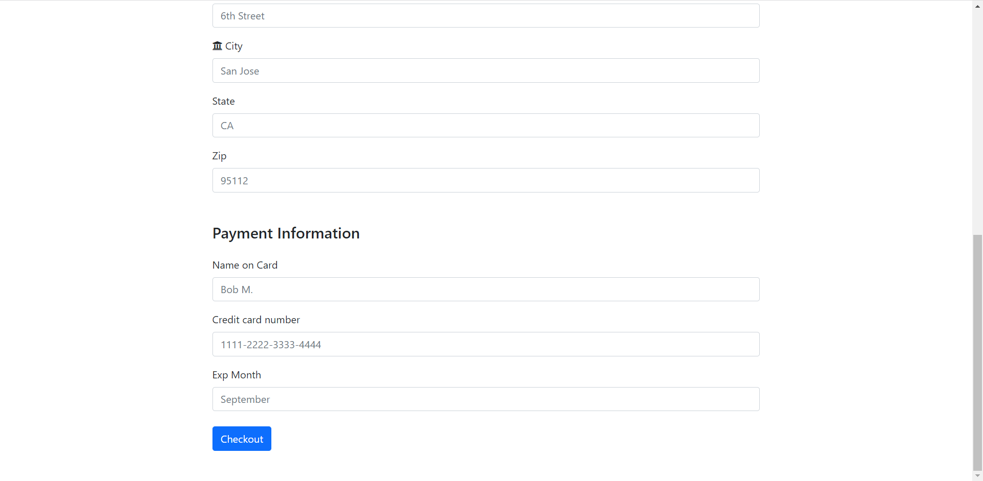

Then, you can see what you have ordered in the order page!

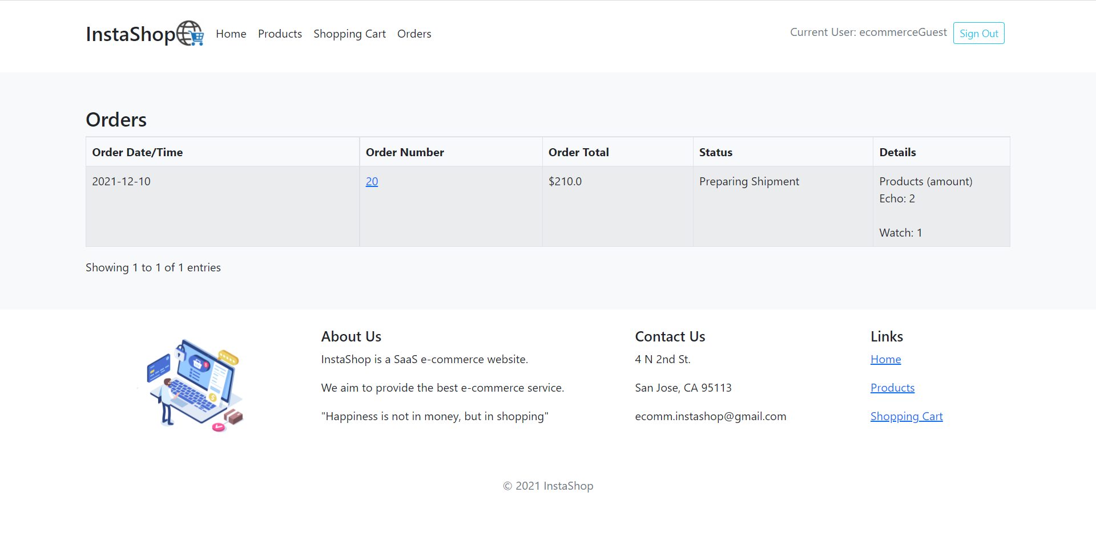

The order page contains the information including order time, order ID, total and the products details for what you have bought.

Enjoy your shopping trip at InstaShop! Add more items to your shopping cart!

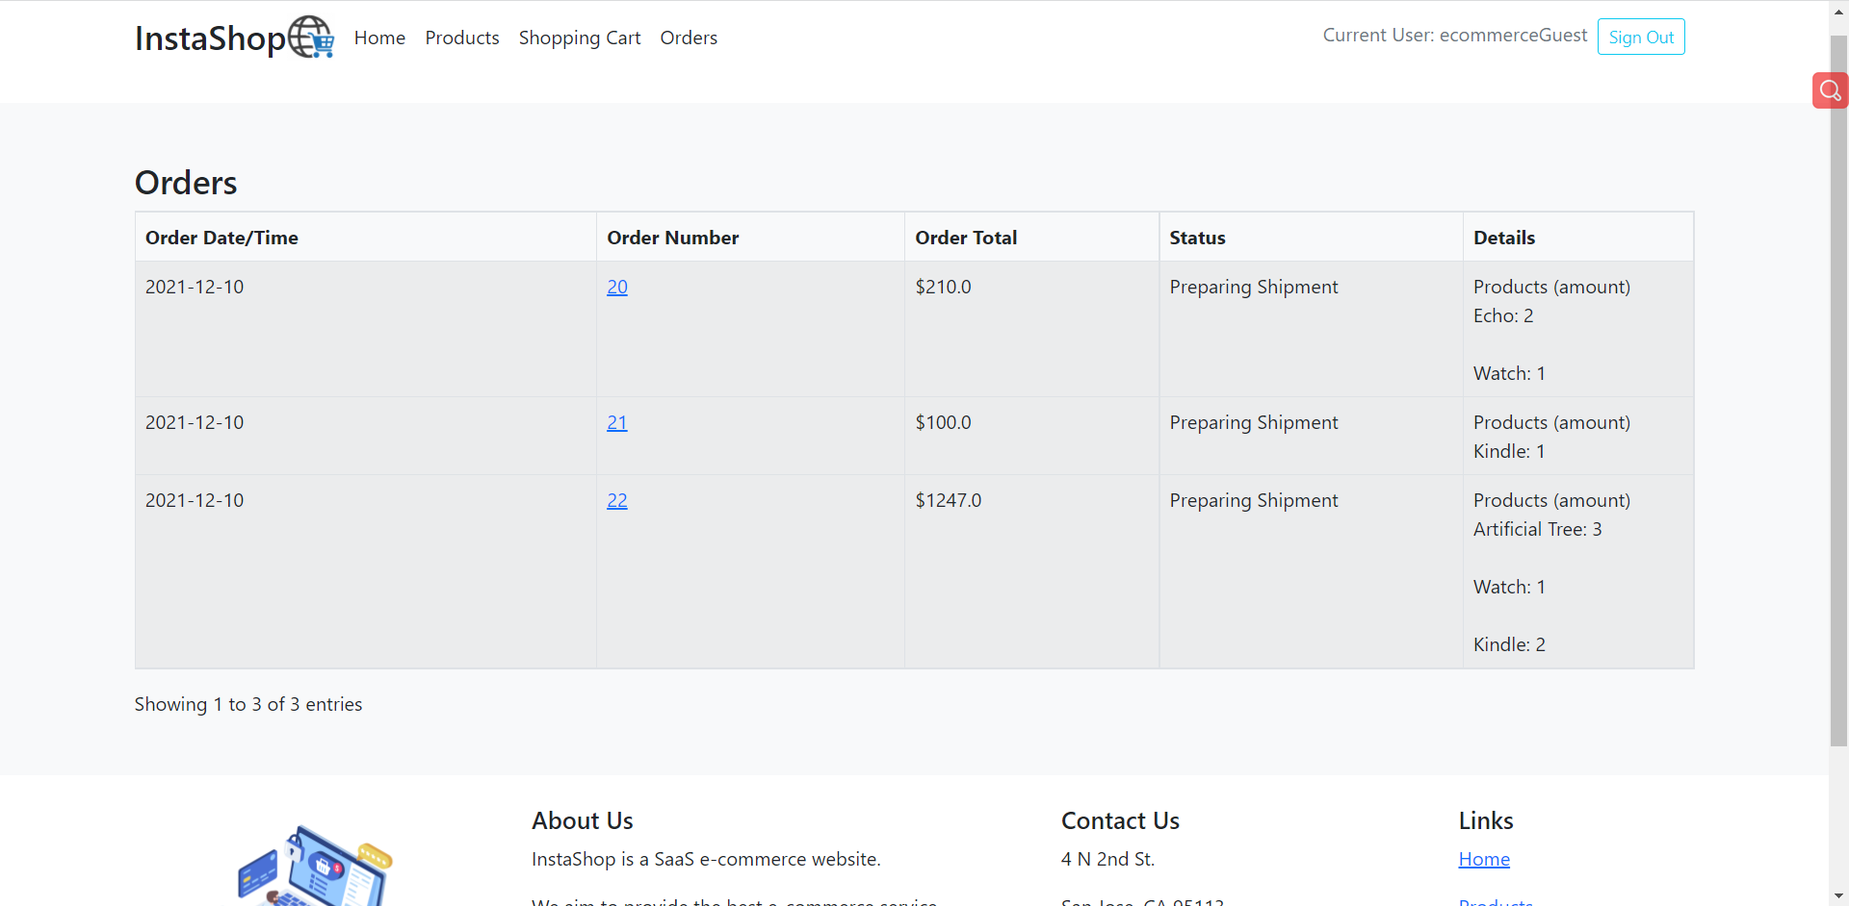

**Test Plan & Expected results**

Test case 1:test the Sign up feature.

expected result: Users can sign up by using their username and password

Test case 2: test the sign in feature

expected result: Users can sign in by using the credentials that they signed up

Test case 3: click ‘Home’, ‘Products’, ‘Shopping Cart’, ‘Orders’ buttons

expected result: These web pages load correctly.

Test case 4: At home page, click each product of top picks

Expected result: Each product information is displayed on the new page and web page is loaded correctly

Test case 5: Click ‘Products’, add each product to the cart

Expected result: all these products can be added to the cart.

Test case 6: Click ‘Shopping Cart’

expected result: shopping cart should have the products that customers chose in the ‘Products’ page. Shopping cart should have the product name, product quantity and the total price of each product. In addition, customers can click the ‘+’ and ‘-’ to increase and decrease the quantity of product.

Test case 7: Click the ‘proceed to pay’ button on the checkout section. Fill out the shipping details and payment information

Expected result: the checkout feature should work properly. Customers click ‘checkout’ button, then this order should be placed successfully

**Take away**

1. We learned to use Django to develop a web application
2. We learned to use Zappa commands to deploy the web application
3. We learned to use Elastic Beanstalk to deploy the web application
4. We learned to use containerization, amazon rds and build CI/CD pipeline to deploy the web application

**Additional effort**

Besides the above-mentioned success deployment, we also tried other approaches to deploy the web app. For instance, we tried to use zappa and Elastic Beanstalk to deploy the web app. We really learned a lot via the overall deployment process. Thus, we also want to mention it here as additional effort.

Use Elastic Beanstalk to deploy the web app:

Use ‘eb create’ command to create the elastic Beanstalk environment, ec2 instance and the S3 bucket.

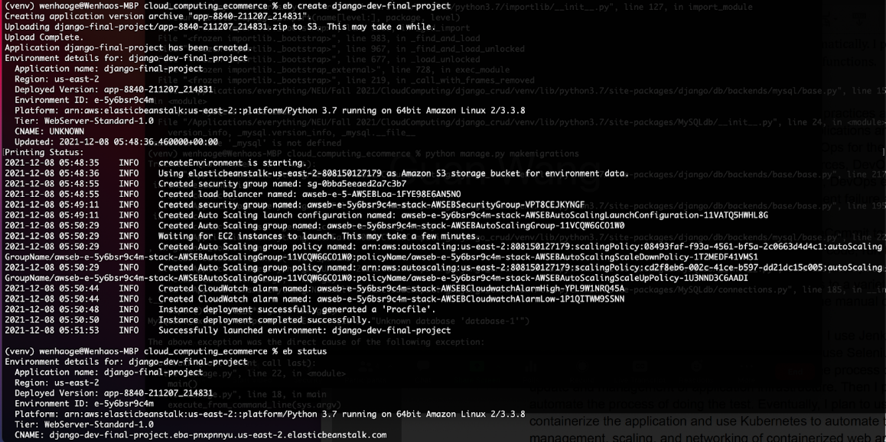

Use ‘eb deploy’ command to deploy the new changes to the environment. Then use the ‘eb open’ command to open the URL in the browser. But the URL did not open.

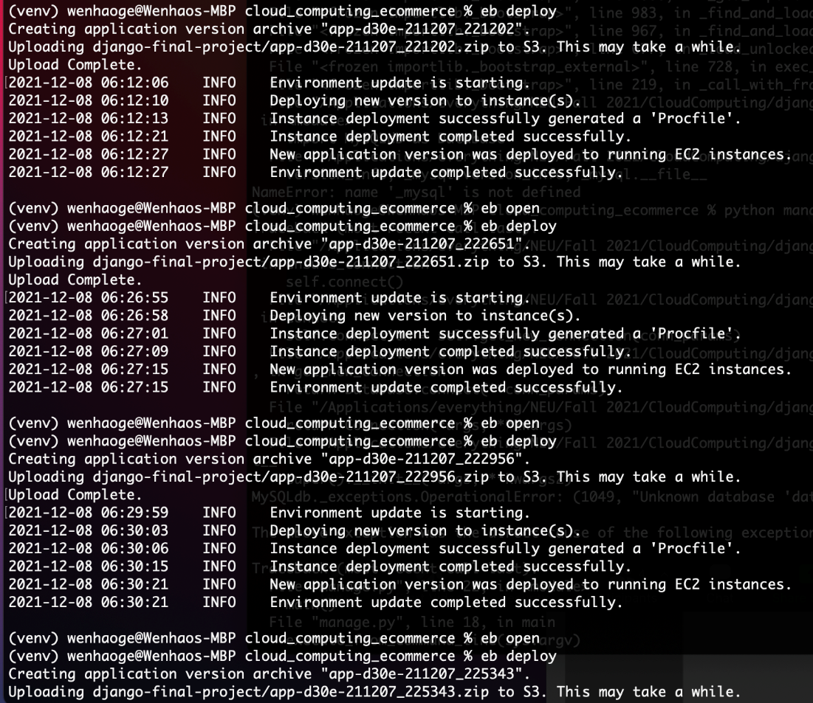

In the logs, we got the errors in the next picture. Then we added a Procfile in the project directory, and added this line into the file:

web: gunicorn --bind :8000 --workers 3 --threads 2

In addition, we added this line in django.config file:

WSGIPath: hw3_ecommerce.wsgi.application

Then we ran ‘eb deploy’ again, but the problem persisted. When we ran ‘eb open’, there was no URL open in the browser.

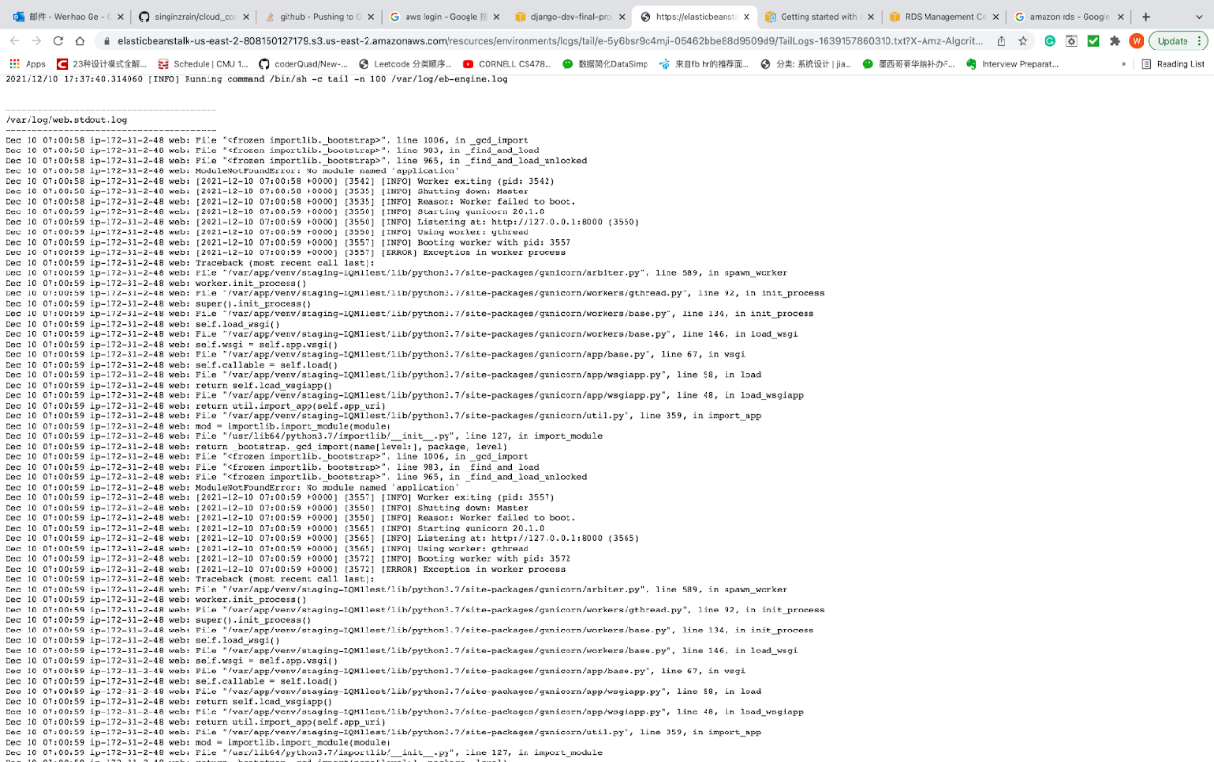

Use Zappa to deploy the web app:

We ran ‘zappa init’, ‘zappa update dev’, ‘zappa deploy dev’ to deploy the web app. The deployment is live, and we got a URL. we opened the URL in the browser, then we got this error in the browser. 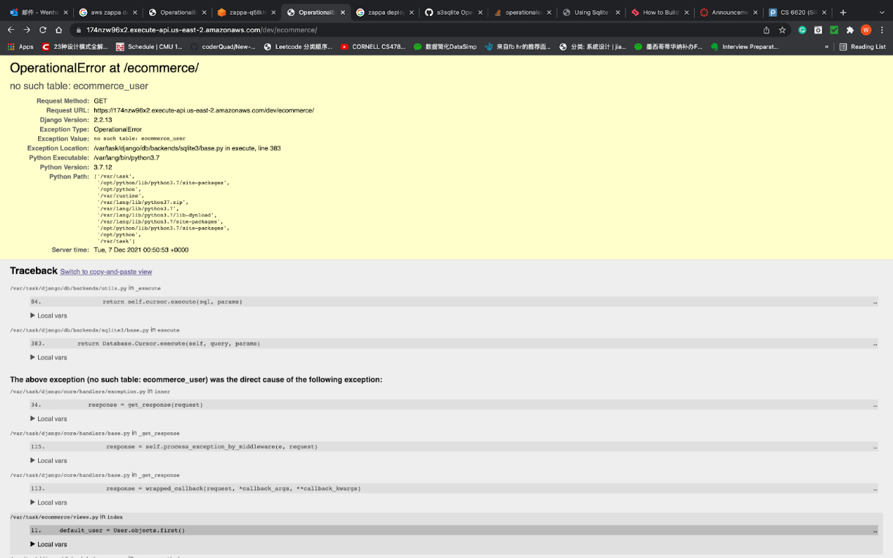

We think the reason is the database was not deployed successfully. Then we took steps to deploy the database.

We ran ‘pip install django_s3_sqlite’ and ‘pip install django_s3_storage’. We created a MySQL database using AWS RDS. Then we ran ‘python manage.py makemigrations’, we got an error: NameError: name ‘_mysql’ is not defined. Our solution is to run ‘pip install pymysql’ and ‘brew install mysql’, then this problem was resolved. Later, we  met with this kind of error:

django.db.utils.OperationalError: (1049, "Unknown database"). we fixed this issue too. In addition, when we ran ‘python manage.py makemigrations’ command, we was met with access denied related issues. we rewrote the correct database name, database username and database password in settings.py file. Then we solved these accesses denied issues.

The deployed URL is

[https://uc3unzghod.execute-api.us-east-2.amazonaws.com/devhttps://uc3unzghod.execute-api.us-east-2.amazonaws.com/dev](https://uc3unzghod.execute-api.us-east-2.amazonaws.com/devhttps:/uc3unzghod.execute-api.us-east-2.amazonaws.com/dev)

The following images shows that something was not loaded correctly. we clicked the ‘Sign in’ button, we typed in the username and password, but we were not able to sign in. we saw ‘Forbidden’ on the screen.

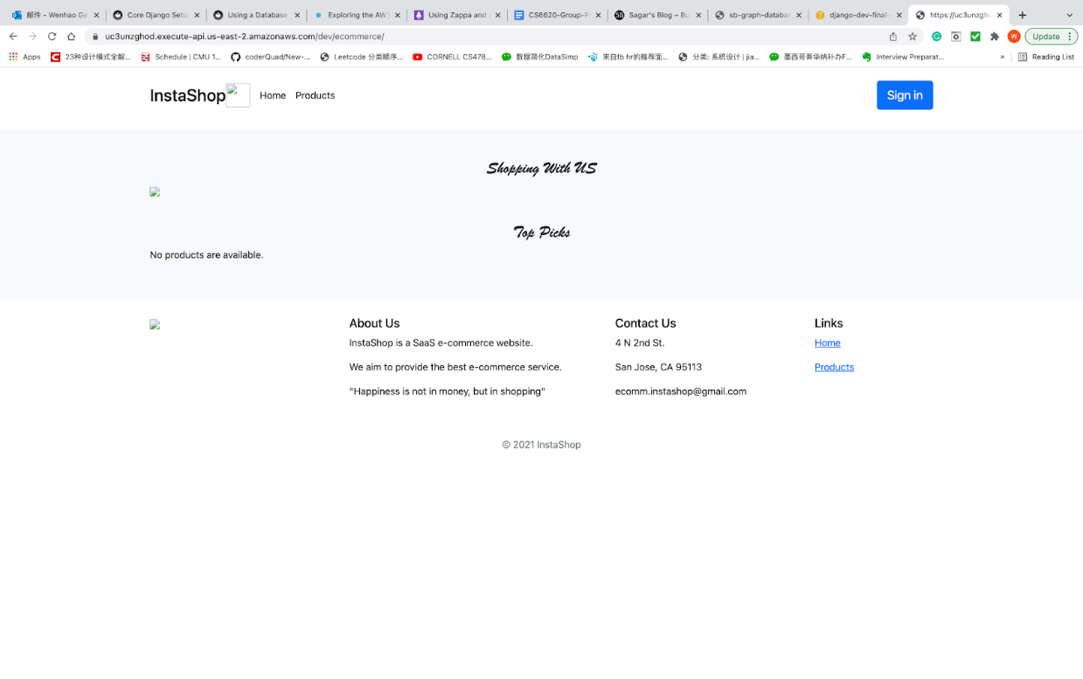

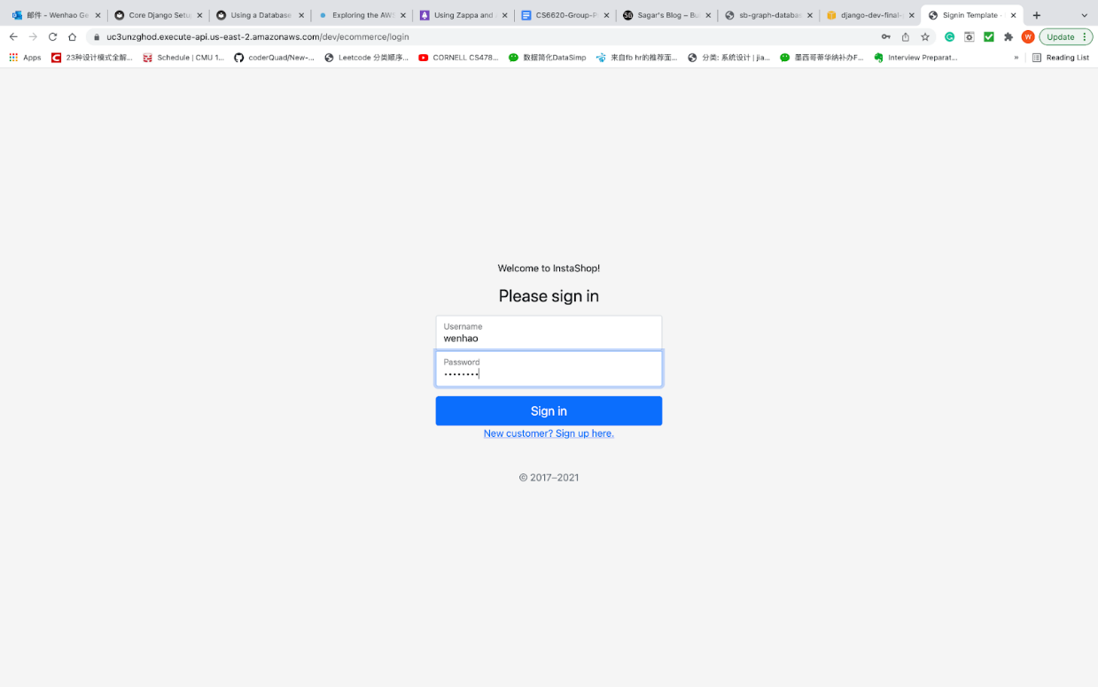

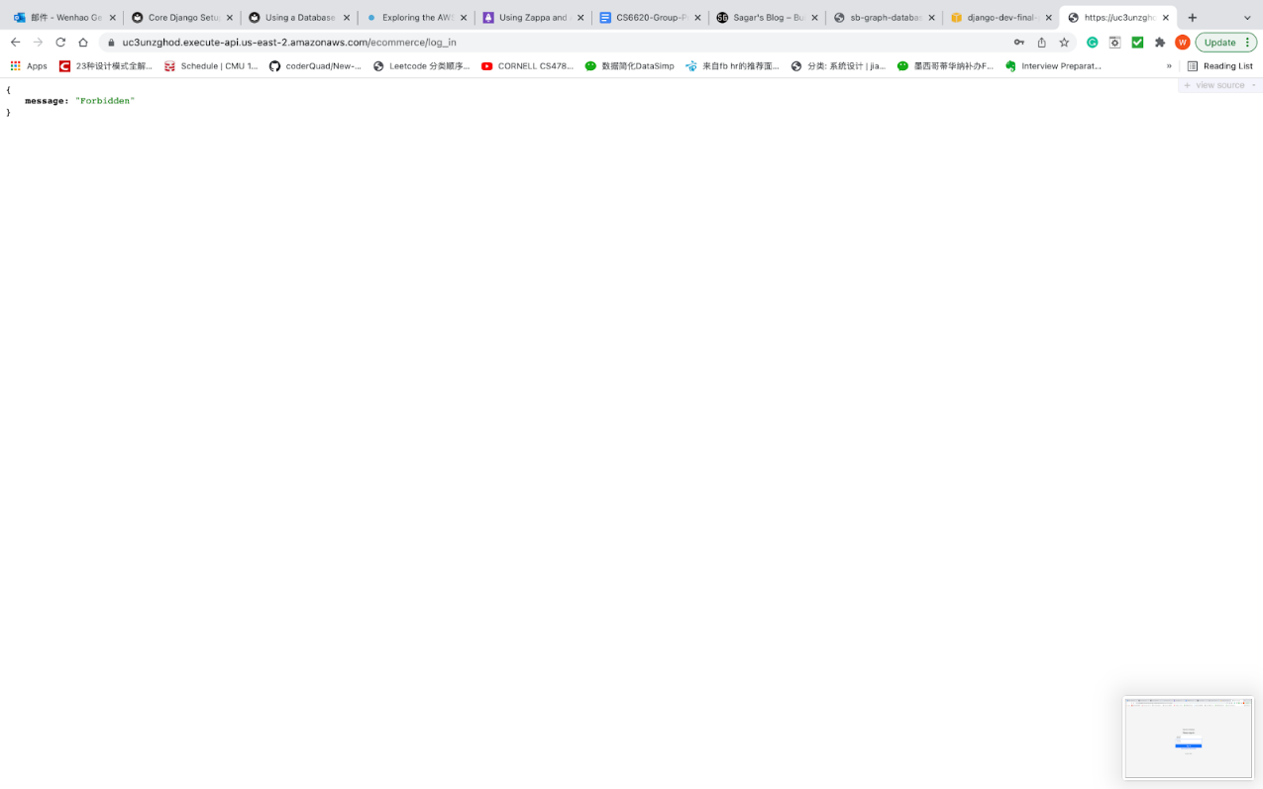

**Executive Summary**

As an overview of this project, we would thank our teammates, Professor Prasad and our teaching assistants first. Without their help, no individual could have achieved so much in just one semester. Through this project, our team have a clear division of labor of each task. We split the whole task into some group tasks and some light individual work. In summary, the process of the Ecommerce SaaS web application includes designing, implementing UI section, connecting to the database and deployment. This experience would be helpful for our understanding of Cloud Computing and build long-term memory.

For the learning outcome – Concept, CICD is the combined practices of continuous integration (CI) and either continuous delivery or continuous deployment (CD). CI/CD bridges the gaps between development and operation activities and teams by enforcing automation in building, testing and deployment of applications. The process contrasts with traditional methods where all updates were integrated into one large batch before rolling out the newer version. Modern day DevOps practices involve continuous development, continuous testing, continuous integration, continuous deployment and continuous monitoring of software applications throughout its development life cycle. The CI/CD practice, or CI/CD pipeline, forms the backbone of modern-day DevOps operations. And for the view part, we have a better understanding of how Django works (with SQLite other storage service, for example RDS) and how it is deployed.

Through the process of deployment and some programming, we understand how the ECS, S3, Lambda, git, code pipeline, Load balancer work better. Also, lots of effort could be favorable to SQL operation and the relationships between various of services of AWS. Through the comprehensive application of them, we believe, in the future, we can cooperate with team members, friends or colleagues to complete larger projects in a more efficient way using what we learnt in this course. We’re very grateful for the experience!